CO3 - Activity6 Sankey Website Flow
Department | AI&DS
Course Code / Course Name | DSA0602/ Data Handling and Visualization
Activity | CO3 - Activity6 Sankey Website Flow
Name | Addula Yaswanth
Register Number | 192324179

Scenario: The analytics team of a travel-booking website tracked 7,280 sessions last month through four stages: traffic source, landing page, next action and outcome. The Sankey diagram below shows the number of sessions on every flow. Three flows are hidden and marked "?".
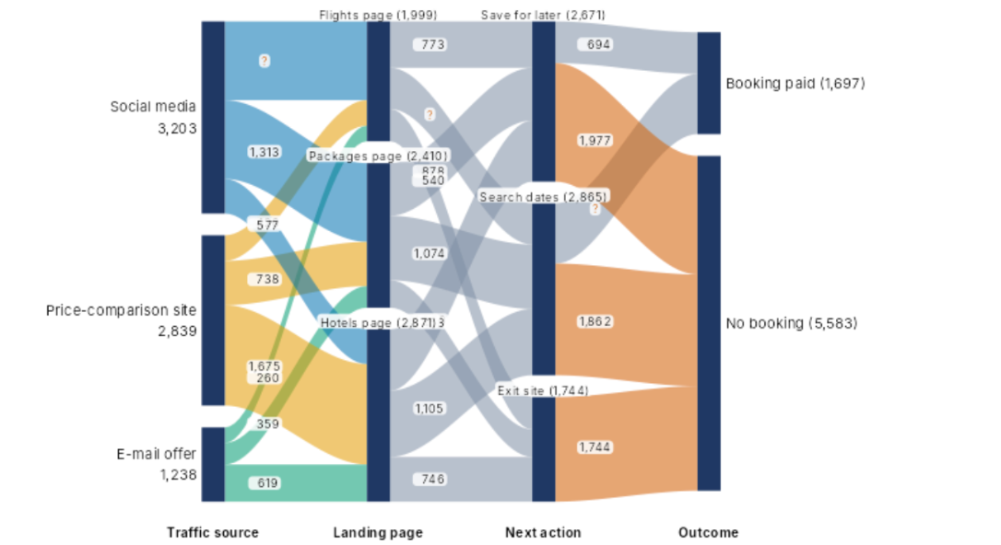

- Using conservation of flow (what enters a node equals what leaves it) find the three hidden flows, showing working: Flights page to Search dates; Search dates to Booking paid; Social media to Flights page. State the rule you used. [4]

Rule used: Total incoming flow = Total outgoing flow.

1. Flights page → Search dates
Hidden flow = Total sessions − Known flows
= 1,999 − 773 − 694
= 532 sessions

2. Search dates → Booking paid
Hidden flow = Total sessions − Known flows
= 2,865 − 694 − 1,977
= 194 sessions

3. Social media → Flights page
Hidden flow = Total sessions − Known flows
= 3,203 − 1,313 − 577 − 738
= 575 sessions

- Compute: (i) the overall conversion rate, i.e. Booking paid as a percentage of all sessions; (ii) the largest single flow into "No booking" or "Exit site"; (iii) the percentage of "Flights page" sessions that go on to "Save for later". [4]]

- Overall conversion rate
Formula:
Conversion rate = (Number of paid bookings / Total sessions) × 100
Given:
Paid bookings = 1,697
Total sessions = 7,280
Calculation:
Conversion rate = (1,697 / 7,280) × 100
= 23.31%

(ii) Largest single flow into “No booking” or “Exit site”
Largest flow into No booking = 1,977 sessions
Flow into Exit site = 1,744 sessions
Comparison:
1,977 > 1,744
Therefore, the largest single flow is 1,977 sessions into No booking.

(iii) Percentage of Flights page sessions that go on to “Save for later”
Formula:
Percentage = (Sessions going to Save for later / Flights page sessions) × 100
Given:
Sessions going to Save for later = 773
Flights page sessions = 1,999
Calculation:
Percentage = (773 / 1,999) × 100
= 38.67%

(c) Design the final Sankey: give four design decisions (node order to reduce crossings, colour rule, labels, what to highlight) and justify each in one line using this data. [4]

- Node order: Arrange the nodes in the order Traffic source → Landing page → Next action → Outcome. This clearly represents the four stages of the travel-booking journey.
- Colour rule: Use consistent colours for traffic sources and different colours for the final outcomes, Booking paid and No booking. This makes the flows easier to distinguish.
- Labels and highlighting: Display the session counts on nodes and flows, and highlight the largest flow of 1,977 sessions into No booking. This helps identify important user behaviour and areas for improvement.
(d) The Sankey is to be printed with 1 cm of node height = 400 sessions. Compute the height in cm of each landing-page node (Packages page, Flights page, Hotels page). [2]
Given:
1 cm = 400 sessions
Formula:
Height (cm) = Number of sessions / 400
1. Packages page
Height = 2,410 / 400
= 6.025 cm
2. Flights page
Height = 1,999 / 400
= 4.998 cm
3. Hotels page
Height = 2,871 / 400
= 7.178 cm

(e) Write R code: a links data frame for the first four flows leaving "Social media" and "Price-comparison site" in the table order of the diagram, a nodes data frame, and the networkD3::sankeyNetwork() call (or plotly) that draws the whole diagram. [4]
R-Code:
# Install the package once if required
install.packages("networkD3")

library(networkD3)

# Links data frame
links <- data.frame(
source = c(0, 0, 0, 0, 1, 1, 1, 1),
target = c(3, 4, 5, 6, 3, 4, 5, 6),
value = c(1313, 577, 738, 575,
773, 540, 1074, 452)
)

# Nodes data frame
nodes <- data.frame(
name = c(
"Social media",
"Price-comparison site",
"E-mail offer",
"Flights page",
"Packages page",
"Hotels page",
"Search dates"
)
)

# Draw the Sankey diagram
sankeyNetwork(
Links = links,
Nodes = nodes,
Source = "source",
Target = "target",
Value = "value",
NodeID = "name",
fontSize = 12,
nodeWidth = 25
)

Output:
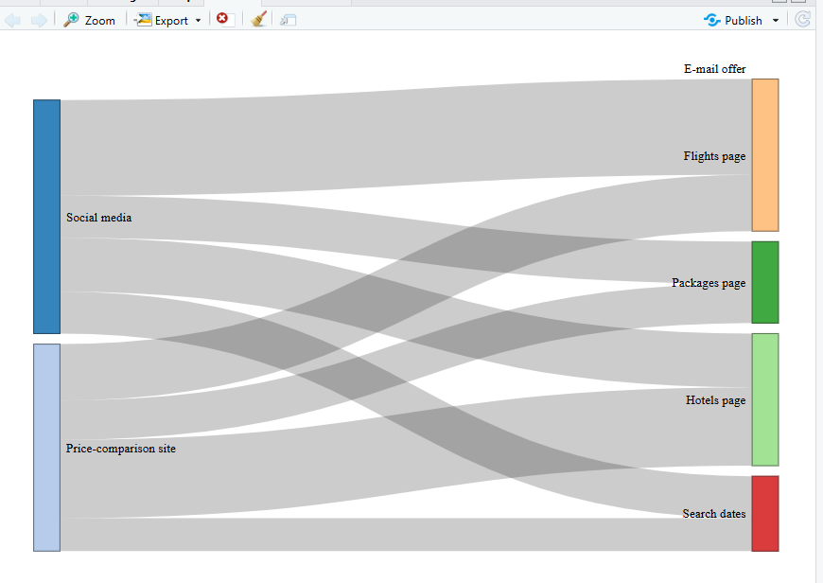

Note: This is illustrative code showing the required data-frame structure. The flow values and links need to be checked against the original diagram before submission, because some labels in the image are unclear.

(f) State two situations in which a Sankey diagram misleads or becomes unreadable, and name one alternative chart for each. [2]

1. Too many flows and crossing lines: The diagram becomes cluttered, making it difficult to trace individual flows. An alternative is a bar chart.
2. Very small flows compared with large flows: Small flows may become difficult to see and compare. An alternative is a table displaying the exact flow values.

